Biology Review Workbook and Problem Set
Complete the workbook below and problems below by inserting your answers. Show all work for full credit. The completed workbook and problem set is due by 3AM 9/3/12.
Chapter 1.1
What biochemical commonalities are there between higher and lower organisms?
Explain how the activities within a cell can be compared to the transportation of a city:
Figure 1.1 outlines the levels of complexity of living organisms. Rewrite this hierarchy here:
Chapter 1.2
How is organic chemistry related to biochemistry?
List /Draw the biologically important functional groups below:
Chapter 1.3
Figure 1.2 shows reactions of phosphoric acid with alcohol and itself. Why are these reactions important in biochemistry?
If the Universe started with the contents being 15 billion Kelvin, how hot is this in Celsius or Fahrenheit?
What are the 3 elements generally thought to be present at the beginning of the Universe and why these 3 elements?
What are the biologically important elements? What processes allowed for the creation of these elements?
What gases were present on Earth 5 billion years ago? How do we know?
Define the term “abiotically” and explain how the term relates to the origin of the Universe:
Draw the structure of 2-aminooxazole and show how it can act as a precursor molecule for nucleotides:
Define the following terms:
Monomer –
Polymer-
Catalyst –
Catalysis –
In Figure 1.6 the building blocks and final products for several biomolecules are shown. Complete the table below with the names of the building blocks and final products:
Building Block | Final Biomolecule

Why is RNA now thought to be the original coding material for life? Explain RNA-World Theory.
What is the Double Origin Theory?
Define the term Protocell:
In Figure 1.8 the term “adaptor RNA” is introduced. Thinking about what they do, by what name are these RNAs called today?
In Figure 1.9 the importance of cell membranes is discussed. Why are membranes so important to the development of more complex organisms?
Looking at Figure 1.10, describe how heat plays a part in the replication process:
Chapter 1.4
Define the following terms:
Genome –
Gene –
Organelle –
Chapter 1.5
How does the Nuclear Region of a Prokaryote differ from the Nucleus of a Eukaryote?
What is the Cell Wall of a prokaryote composed of?
Chapter 1.6
How are Mitochondria and Chloroplasts similar?
Draw pictures of both the prokaryotic and eukaryotic cells. Be sure to label all of the important features of each:
Define the following terms including their function and location in the cell:
Nucleus –
Mitochondria –
Membrane –
Endoplasmic Reticulum –
Ribosome –
Chloroplast –
Golgi Apparatus –
Lysosomes –
Peroxisomes –
Glyoxysomes –
Vacuoles -
Organelles are attached to the cytoskeleton. Why do you think this is necessary? What purpose(s) does the cytoskeleton serve?
Summarize the differences between Prokaryotes and Eukaryotes:
Prokaryotes | Eukaryotes

Chapter 1.7
List the 5 kingdoms of living organisms and give two examples of each:
List the 3 domains of living organisms and give two examples of each:
Chapter 1.8
What is “mutualism”?
What is the evidence that some eukaryotic organelles developed from endosymbiosis?
Chapter 1.9
Define Oxidation and Reduction and show an example reaction including the oxidation states for all elements in the reaction:
ATP is the most important energy molecule in biochemistry. Explain why it is important and how it produces energy.
Chapter 1.10
Define the term spontaneity –
Chapter 1.11
Define the terms:
Endergonic –
Exergonic –
What does equilibrium mean in terms of energy?
Chapter 1.12
Define the terms:
Entropy –
Enthalpy –
Gibbs Free Energy –

Thermodynamics involves the Free Energy, Enthalpy and Entropy of systems. Complete the table below showing how the combination of these terms determines the spontaneity of a reaction:
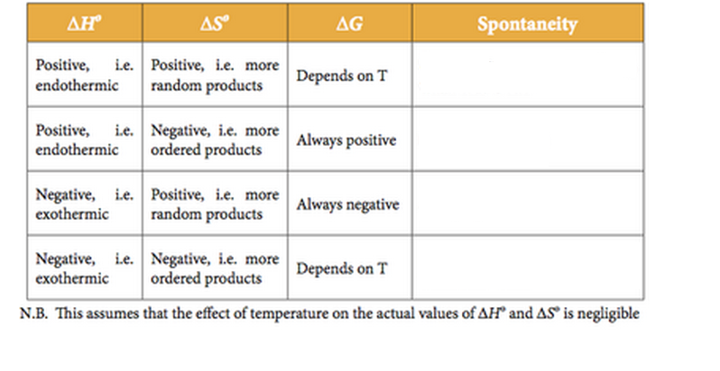

Problem Set:
- Biomolecules interact with one another through molecular surfaces that are structurally complementary. How can various proteins interact with molecules as different as simple ions, hydrophobic lipids, polar but uncharged carbohydrates and even nucleic acids?

- What structural features allow biological polymers to be informational macromolecules? Is it possible for polysaccharides to be informational molecules?

- Why is it important that weak forces, not strong forces, mediate biomolecular recognition?

- Why does the central role of weak forces in biomolecular interactions restrict living systems to a narrow range of environmental conditions?

- Describe what is meant by “cells are steady-state systems.”

- In order to give rise to more highly complex structures, what capabilities did the first biological molecules have to have?

- Why is molecular information so important for classifying and tracing the evolutionary relatedness of bacterial species but less important for vertebrate species?

- The first theories to explain the similarities between bacteria and mitochondria or chloroplasts suggested that an early eukaryotic cell actually engulfed but failed to fully digest a free-living prokaryotic cell. Why is such an event unlikely to account for the origin of mitochondria and chloroplasts?

